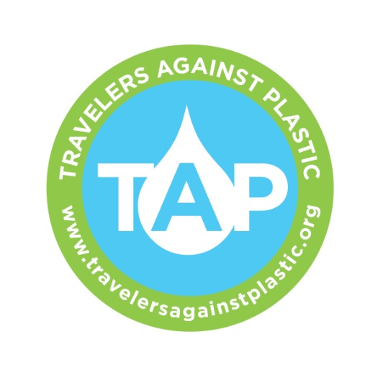
WATER PURIFICATION-ITS EASIER THAN YOU THINK

CLEAN WATER- We all know we can’t drink the water in developing countries because it might make us sick from any number of microscopic critters which could cause diarrhea, abdominal cramps or worse. Most people buy bottled water which has huge environmental impacts as well as being expensive and possibly unhealthy. What to do?

Travel prepared to clean your own water or use water in containers provided by hotels and operators if they have it. WHY?
- To avoid creating a trail of plastic water bottles everywhere you go
- To ensure the safety and supply of your water
- To save money and time

IT’S EASY: There are many bottles you can choose from. We love Liberty Bottles.
There are also many ways to clean your water which fall into three categories: electronic, chemical and mechanical.
Example of electronic: STERIPEN
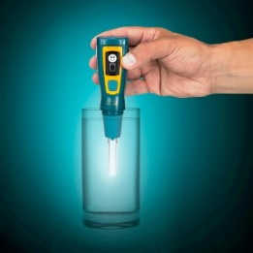
- A small light weight device that cleans the water with ultra-violet light
- One Steri-PEN cleans 8,000 bottles of water. One charge of the battery will last for one 10-14 day trip.
- The technology is proven and safe
- Cost: $65-140
- Cost per bottle of water: .01cents
You can purchase on the TAP website. (www.travelersagainstplastic.org)

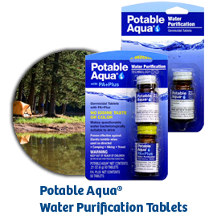
Example of chemical: POTABLE AQUA TABLETS
- Proven effective
- Simple to use
- Takes about 35 minutes to take effect
- Cost: $6-8 per bottle of tablets
- Cost per bottle of water: .27 cents

Example of mechanical: GRAYL- The Water Filtration Cup
- Works like a coffee press
- 16oz of clean water in 15 seconds
- Easy to use- no sucking or squeezing, pumping or batteries
- Cost: $69 for the cup and $39 for a purifier attachment
- Filters flavor, odor, particulates and many heavy metals (i.e. lead, arsenic, chromium) and chemicals (i.e chlorine, benzene, chloroform) plus:
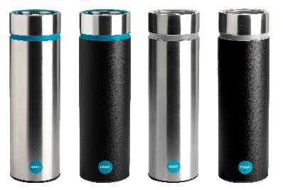
  - Filter (included): 99.99% of bacteria (i.e E.Coli, Salmonella) and 99.94% of protozoa (i.e Cryptosporidium, Giardia)
  - Purifier (optional): 99.999% of bacteria and protozoa plus viruses (i.e. Hepatitis A, SARS)- ideal for 2nd and 3rd World travel
- 300 uses per replaceable Filter and Purifier
You can purchase on the TAP website. (www.travelersagainstplastic.org)
Use Promo code GRAYL-LOVES-TAP and Grayl will donate 5% to TAP.

________________________________________________________________________________

For more information go to TAP www.travelersagainstplastic.org . Please consider signing the pledge not to use plastic water bottles while traveling. And then be the change you want to see in the world.

________________________________________________________________________________

Why bother?

Better for the environment
- 24 million gallons of oil are needed to produce a billion plastic bottles.
- Plastic bottles take 700 years to begin composting.
- 90% of the trash in the ocean is from plastic.
- Eighty-six percent of single-use plastic bottles become landfill or litter in the US.
- PET is made from crude oil. PET bottles produce toxic emissions at rates of 100 times that of glass.

Cheaper
- Bottled water can cost as much $10 per gallon. We are paying 2 to 4 times the cost of gasoline for a product that is virtually free.
- If tap water cost the same as the cheapest bottled, monthly water bills would come to $9,000.

Health
- Antimony, which is found in PET plastic bottles, in small doses can cause dizziness and depression; in larger doses it can cause nausea, vomiting and death.
- This is increased by storage in heated areas. Where was your bottle of water before you got it?

DO THE MATH
In the first two months of 2012, 8.1 million U.S. citizens traveled abroad according to data released by the U.S. Office of Travel & Tourism Industries.
8.1 million travelers over two months =48.6 million a year (estimated)
3 bottles a day for one 2 week trip= over 3.4 billion plastic water bottles used.
Reuse bottles at home as well
Three corporations dominate the bottled water market in the US. Pepsi has 13% of the market and Coke has 11%, both of which resell treated tap water, by putting it through an energy intensive process called reverse-osmosis. This process takes more energy than turning seawater into drinking water.
San Francisco's tap water comes from Yosemite National Park and is so pure the EPA does not require it to be filtered. A bottled of Evian water at $1.35 could be refilled with San Francisco tap water once a day for over ten years before the cost would total $1.35.
Be the Change. TAP

